EXPERIMENT 6:
To learn the demonstration of Quantum Tunneling is analysed and the key learning points are
observed using nano hub simulation tool
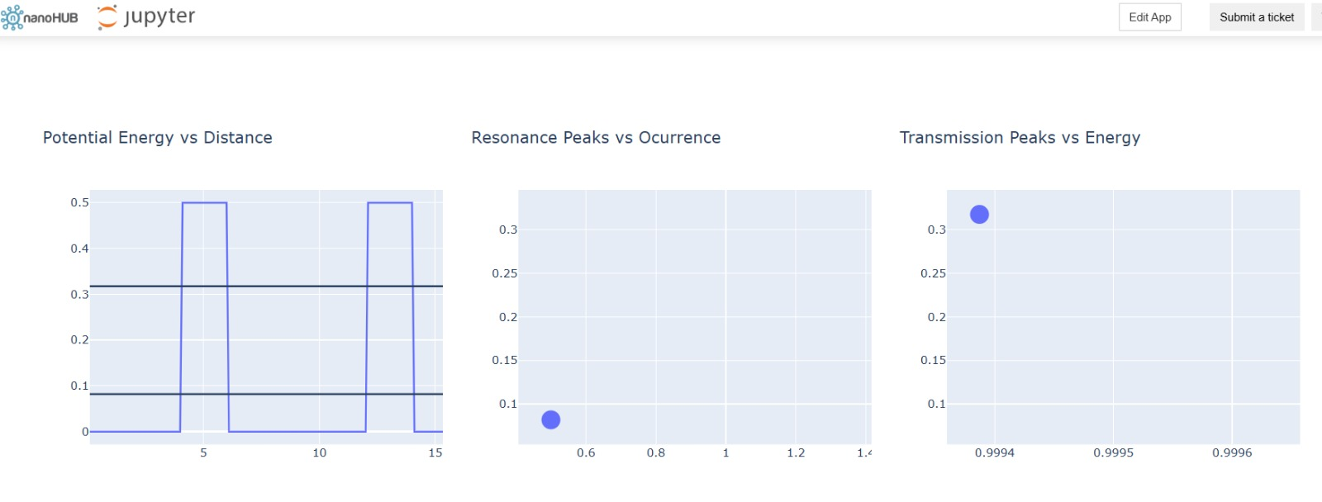
This experiment is performed to understand the phenomenon of quantum tunneling and analyze how particles pass through a potential barrier using NanoHUB simulation.

Case study 1 : Analysis the transmission co-efficient Vs Energy characteristics on refined grid
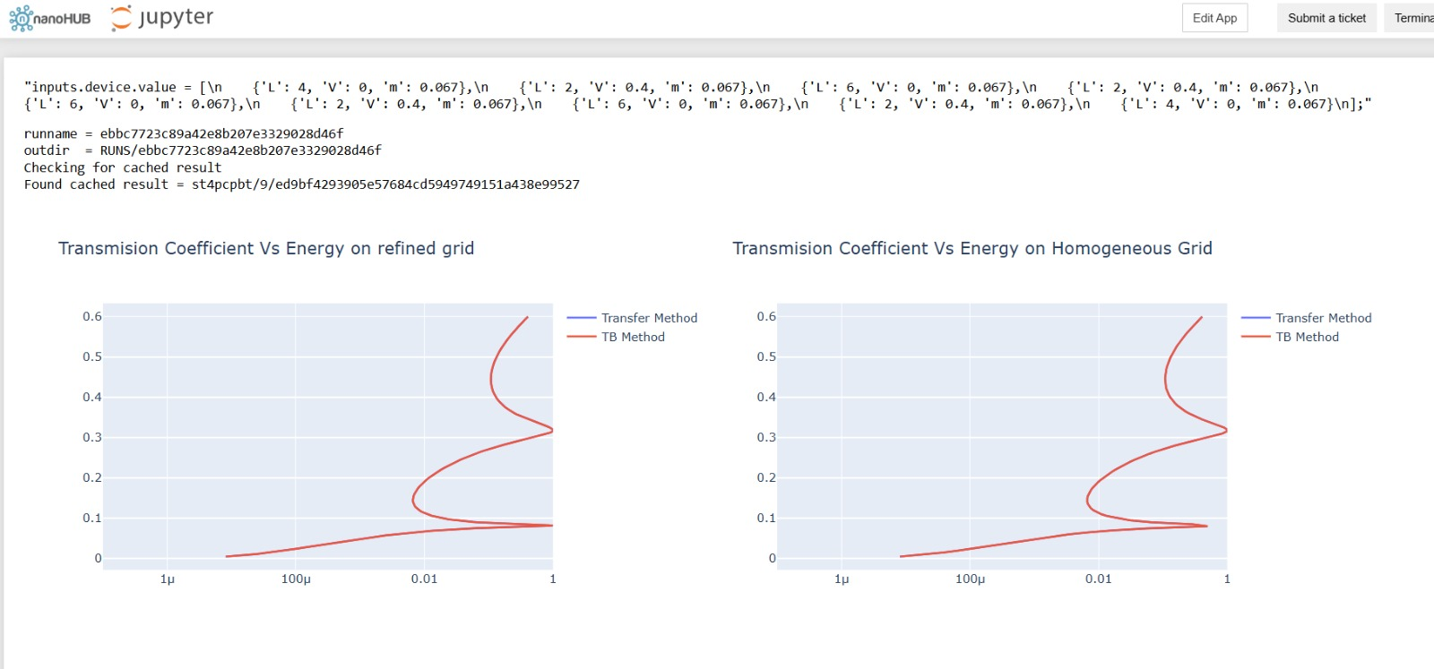
This case study is performed to study how the transmission probability of electrons changes with their energy through a potential barrier. A refined grid is used to obtain more accurate simulation results

Case study 2 : Analysis the Reflection co-efficient Vs Energy on Homogeneous Grid
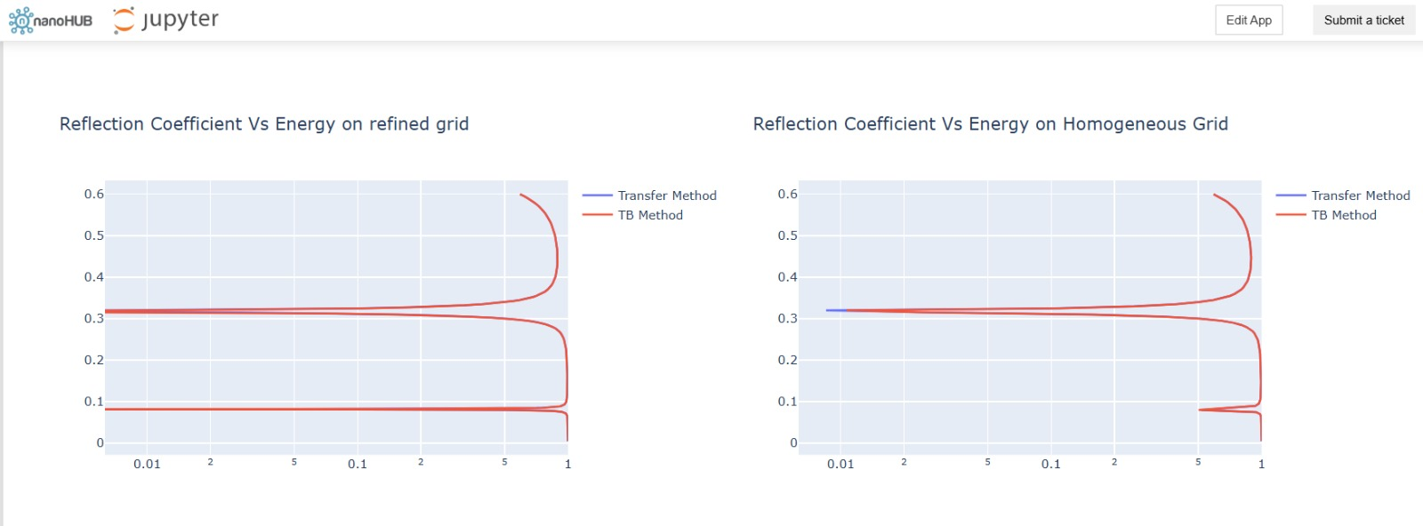
This case study is performed to study how the reflection probability of electrons changes with their energy when interacting with a potential barrier. A homogeneous grid is used to obtain consistent and reliable simulation results.

